**THE CLOSURE**

                                                                                      -Arpit Goel, Dehradun Institute of Technology

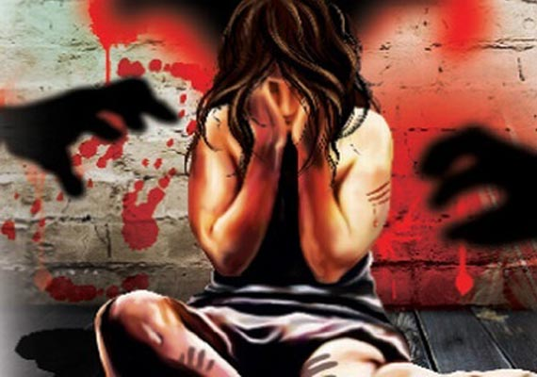

Grappling the leftover straws,

Empty are my hands.

Hands are sore from searching

On red sprawling sand.

The Earth brown still has marks

Her blood still soaked red.

She lay there, I found her,

Laying silent like on her bed.

Killer absconds, I am not fond

Of events that have ensued.

I live, lie, lay, sit on ground,

People now call me shrewd.

Khaki people tell me tales,

"Sir the trail has gone cold".

Boldly tread they in house, and say,

"On suspicion alone they cannot hold".

The ground reeking of her sweat

I touch my ear to ground.

She shouts and screams, I can hear

Her screeching and her wailing sound.

She must have pleaded, bleat like sheep

My poor, poor girl.

I'll give my tooth, strike a nail

Until the criminal unfurls.

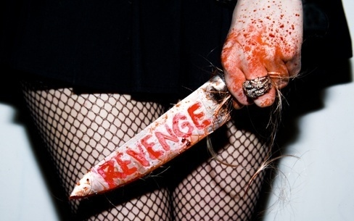

The ‘MonsterMan’ ,TV calls him.

I sit in day, through night.

Hear them speak, repeat,

Explain the grisly sight.

Closure, i seek I'll get

the day I kill him self

my mission is to search he who delves

torture and make him yelp